**Q1:**

Chmod775: will give read, write and execute permission to the owner of the file.

Chown: changes the ownership of the file or directory.

Grep: to search for file or word with certain string.

Tar: an archive format

Yum: tool to remove, install and update packages.

=> Perform the following commands:

a) creat two files simultaneously

b) Copy the data from fileOne to fileTwo

c) create a file and move it to directory

d) delete the directory along with file

e) Show system date

f) show working directory

g) Run any application and terminate it using kill command and process id

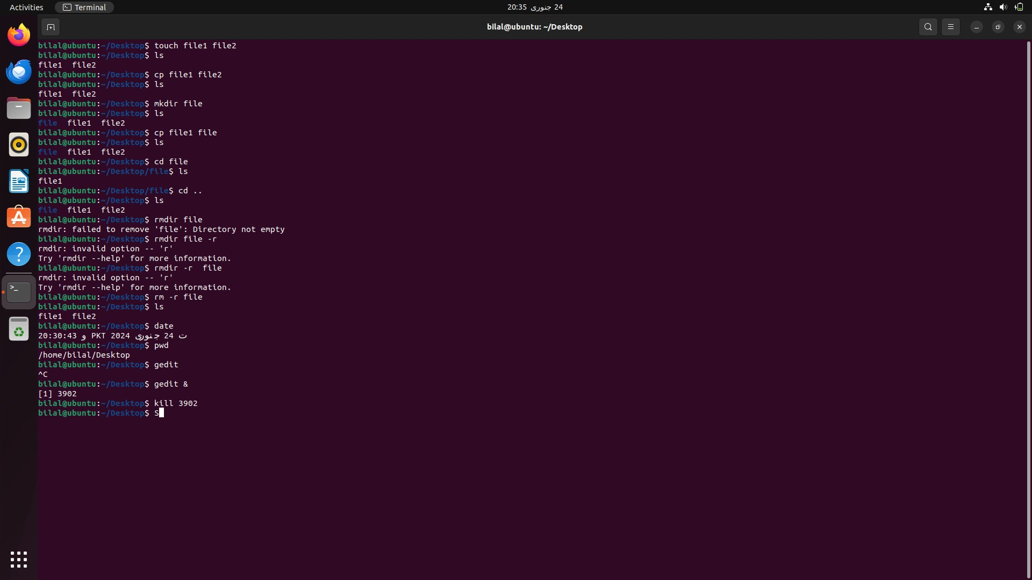

**Q2:**

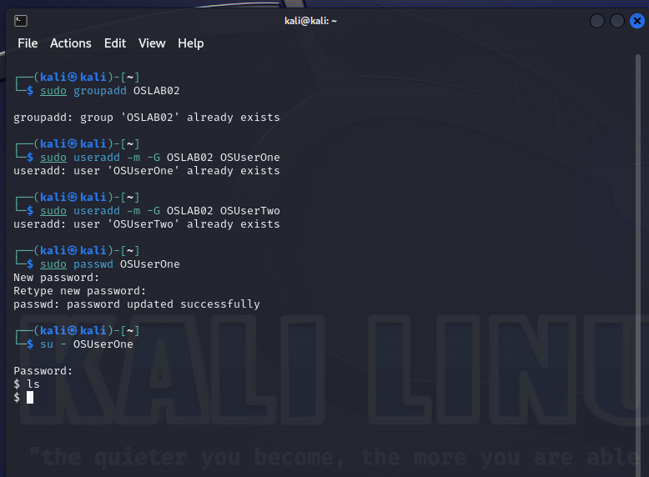

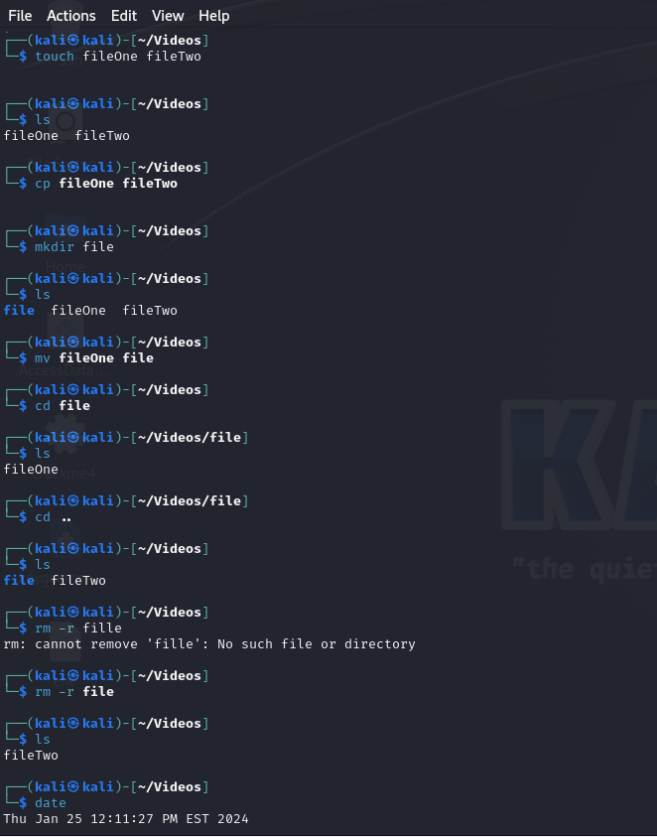

Before Kill command:

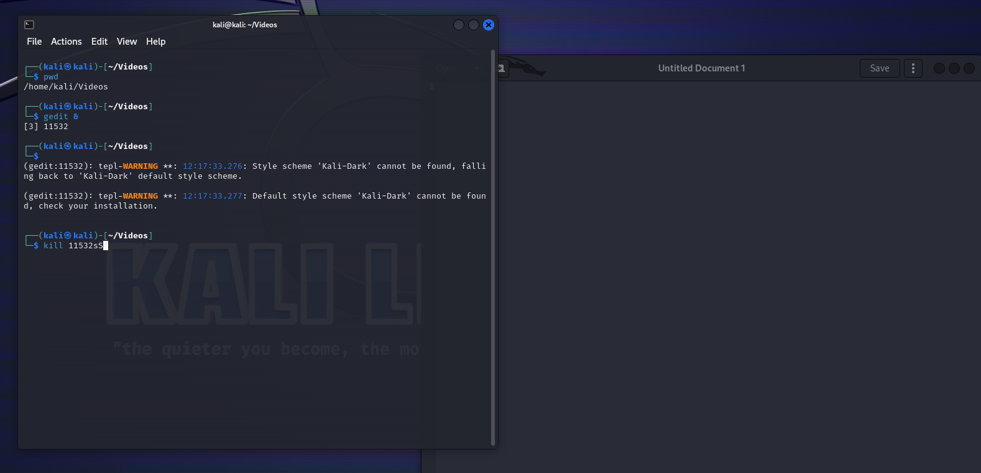

After Kill command:

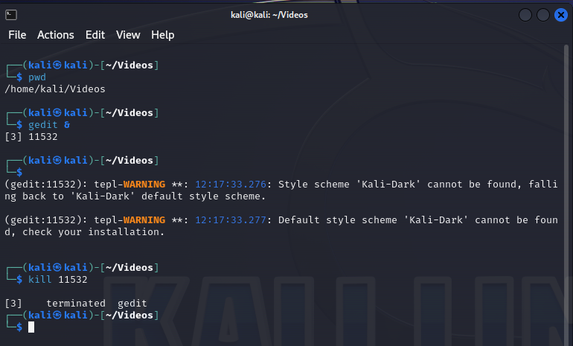

**Q3:**

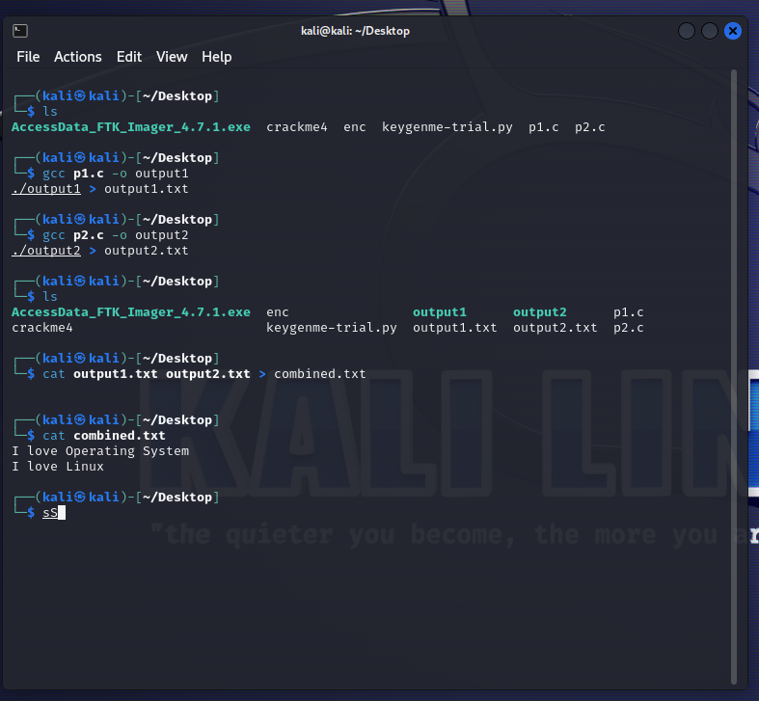

**Q4:**

